THE MAIN PROGRAM

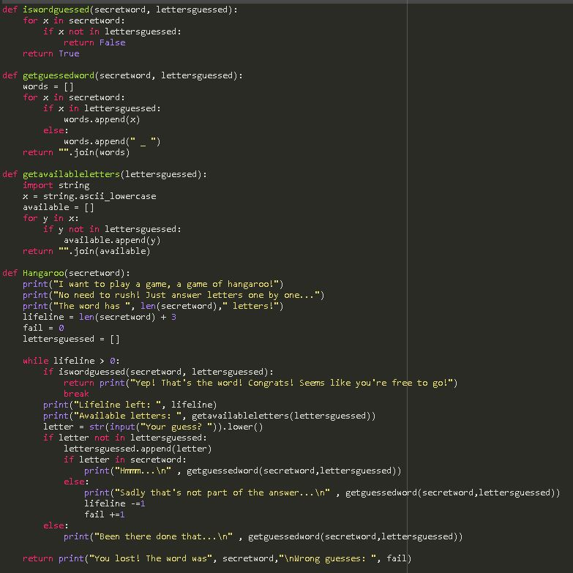

RUN FILE WITH

Hangaroo(“secretword”)

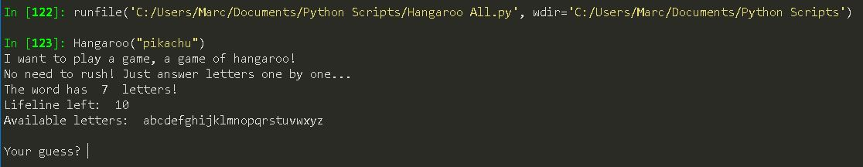

GUESSED CORRECTLY RESULT

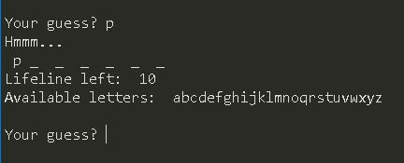

DID NOT GUESSED CORRECTLY RESULT

LIFELINE SUBTRACTS

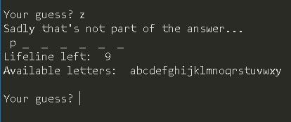

REPEATED GUESS RESULT

NO LIFELINE SUBTRACT \*only shows 2 lifeline since errors were commited until 2 lifelines were left\*

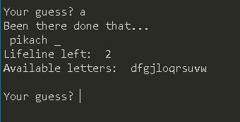

GUESSING THE WORD RESULT

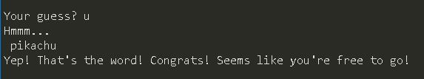

FAILED TO GUESS THE WORD

